ML LAB - 7: Ensemble Learning

Aim:
To understand and implement Ensemble Learning techniques (Bagging, AdaBoost, Gradient Boosting, and Stacking) applied to the Breast Cancer dataset.

1. Setup and Data Loading
import pandas as pd
import matplotlib.pyplot as plt
import seaborn as sns
from sklearn.datasets import load_breast_cancer
from sklearn.model_selection import train_test_split
from sklearn.metrics import accuracy_score, confusion_matrix, classification_report, roc_curve, auc
data = load_breast_cancer()
X = pd.DataFrame(data.data, columns=data.feature_names)
y = data.target
X_train, X_test, y_train, y_test = train_test_split(X, y, test_size=0.3, random_state=42)

2. Bagging Classifier
from sklearn.ensemble import BaggingClassifier
from sklearn.tree import DecisionTreeClassifier
bagging_clf = BaggingClassifier(estimator=DecisionTreeClassifier(max_depth=3), n_estimators=50, random_state=42)
bagging_clf.fit(X_train, y_train)
evaluate_model(bagging_clf, "Bagging", "bagging")
--- Bagging Performance ---
Accuracy: 0.9591
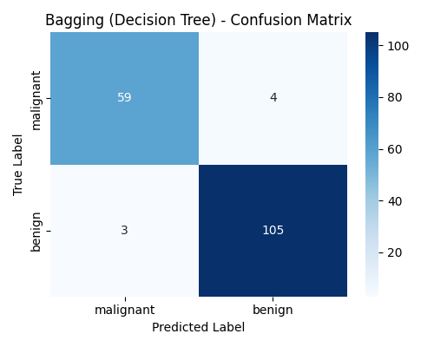
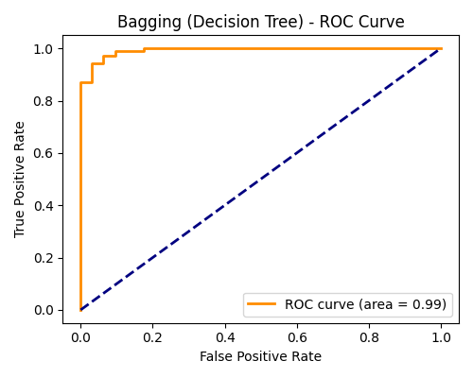

3. AdaBoost Classifier
from sklearn.ensemble import AdaBoostClassifier
ada_clf = AdaBoostClassifier(n_estimators=50, random_state=42)
ada_clf.fit(X_train, y_train)
evaluate_model(ada_clf, "AdaBoost", "adaboost")
--- AdaBoost Performance ---
Accuracy: 0.9766
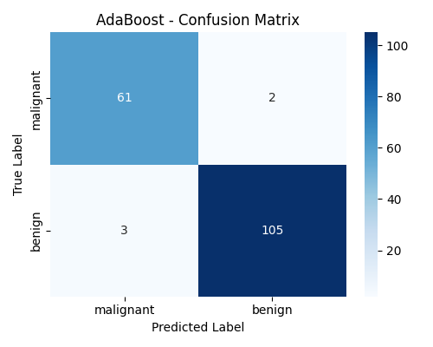
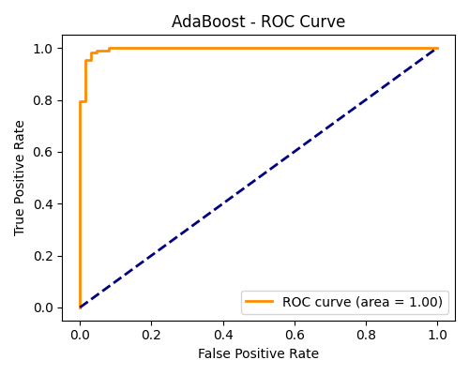

4. Gradient Boosting Classifier
from sklearn.ensemble import GradientBoostingClassifier
gb_clf = GradientBoostingClassifier(n_estimators=100, learning_rate=0.1, max_depth=3, random_state=42)
gb_clf.fit(X_train, y_train)
evaluate_model(gb_clf, "Gradient Boosting", "gradient_boosting")
--- Gradient Boosting Performance ---
Accuracy: 0.9591
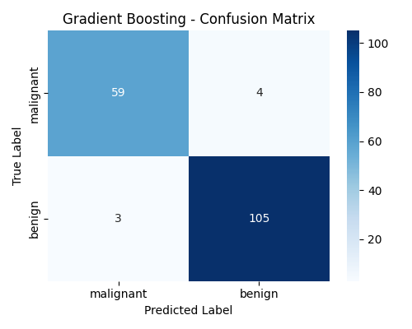
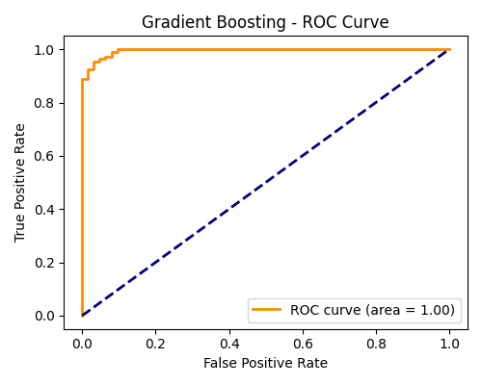

5. Stacking Classifier
from sklearn.ensemble import StackingClassifier
from sklearn.linear_model import LogisticRegression
from sklearn.svm import SVC
from sklearn.ensemble import RandomForestClassifier
estimators = [
('rf', RandomForestClassifier(n_estimators=50, random_state=42)),
('svc', SVC(probability=True, random_state=42))
]
stacking_clf = StackingClassifier(estimators=estimators, final_estimator=LogisticRegression())
stacking_clf.fit(X_train, y_train)
evaluate_model(stacking_clf, "Stacking Classifier", "stacking")
--- Stacking Classifier Performance ---
Accuracy: 0.9708
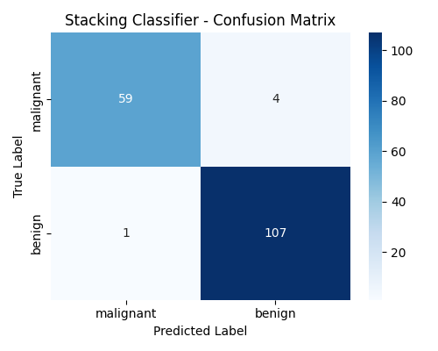

6. Model Comparison
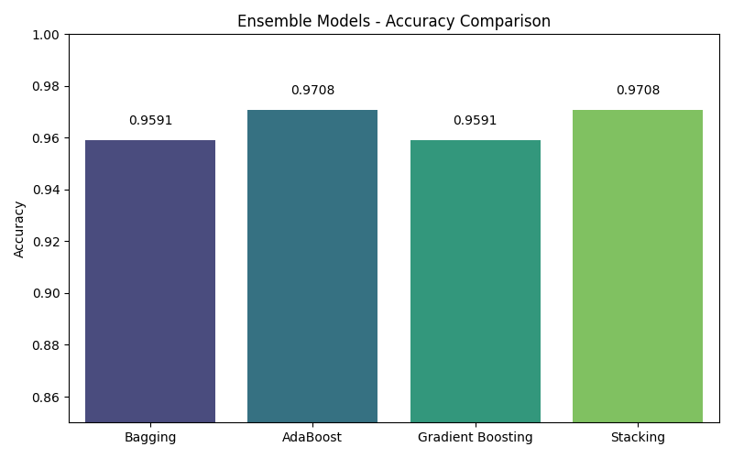

Conclusion:
Ensemble learning methods significantly enhance performance. AdaBoost and Stacking proved to be the most accurate on the Breast Cancer dataset, while Bagging and Gradient Boosting also demonstrated strong results.

